Matthew Garcia Nieves
Enhancement One: Software Design and Engineering
10/15/2026

Artifact Description
The artifact I selected is my Inventory Tracker Android application from CS 360 Mobile Architecture and Programming, which I created in 2026. The app allows users to create an account, log in, and manage inventory by adding items, changing quantities, deleting items, and receiving SMS inventory alerts.
Why I Selected It and What I Improved
I selected this project because it gave me a chance to improve an application I had already built instead of starting over. The original Inventory Tracker worked, but after reviewing the code I found several areas that could be improved. It also gave me a good way to show skills I have developed with Java, Android Studio, SQLite, user input, and connecting the interface of an application to its database.
I made four main improvements to the application. I added validation to prevent invalid or negative inventory quantities from being entered. The quantity field limits what can be entered through the keyboard, and I also added checks in the Java code to reject negative quantities or values that cannot be converted into a number. I added IN STOCK, LOW STOCK, and OUT OF STOCK statuses so the user can quickly see the condition of an item. A quantity of zero is OUT OF STOCK, quantities from one through five are LOW STOCK, and anything above five is IN STOCK. The SMS feature was updated along with this so an alert can be sent when an item is added or updated with a quantity of five or fewer instead of only when it reaches zero.
I also added a search feature that allows the user to find inventory by item number or name instead of having to look through the entire list. I used the SQLite LIKE operator to allow partial matches, so the user does not have to enter the exact item name or number. I also used placeholders in the query instead of putting the search text directly into it. The matching records are then displayed in the inventory table, and the user can clear the search to return to the full list.
The last improvement focused on security. During my code review, I found that the original application stored account passwords as plain text in the database. I changed this so new passwords are stored using a random salt and PBKDF2 hash. When a new account is created, the program generates a random 16-byte salt and uses PBKDF2 with HMAC-SHA256 and 100,000 iterations to create a 256-bit hash. The salt and hash are converted to Base64 and stored together in the password column of the SQLite users table, separated by a colon. I also changed the login process so it uses the saved salt to hash the entered password and compare it with the stored hash. This allows the application to check a password without storing the original password as plain text.
Testing and Verification
After reading my instructor's feedback, I went back into Android Studio to run additional tests and document the results. I tested quantities of zero, five, and six to make sure the inventory statuses changed at the correct values. All three worked as expected. Zero displayed OUT OF STOCK, five displayed LOW STOCK, and six displayed IN STOCK. The application also displayed an SMS alert notification when I added the item with a quantity of five.
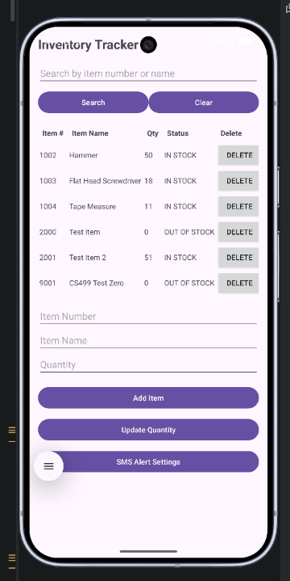
Figure 1. Zero-Quantity Test. The application accepted a quantity of zero and correctly displayed the item as OUT OF STOCK.
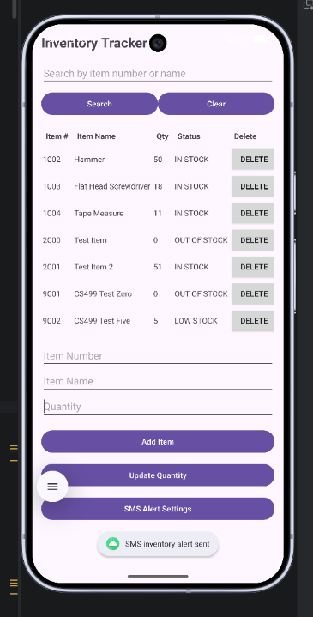
Figure 2. Low-Stock Test. An item with a quantity of five displayed LOW STOCK, and the application showed an SMS alert notification.
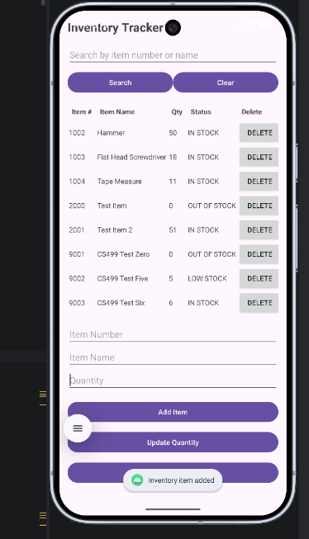
Figure 3. In-Stock Test. An item with a quantity of six displayed IN STOCK, confirming that quantities above five are no longer considered low stock.
I also tried entering a negative quantity and letters into the quantity field. The field would not allow either through normal keyboard input. I had already added checks in the Java code to reject these values if they were entered another way.
Next, I tested the search feature by entering a value that did not match any inventory records. The application cleared the results and displayed a message saying no matching items were found. I then searched for CS499, which returned the three test items I had added without displaying the unrelated inventory records.
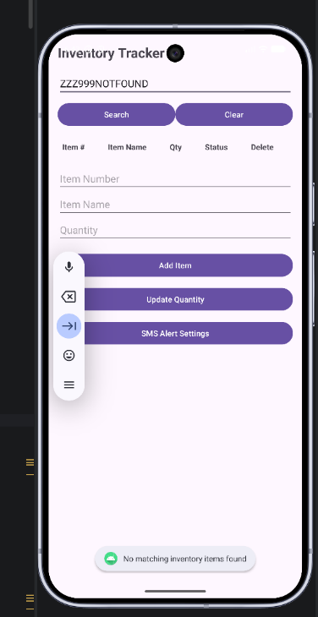
Figure 4. Unsuccessful Search Test. Searching for ZZZ999NOTFOUND returned no records and displayed the message "No matching inventory items found."
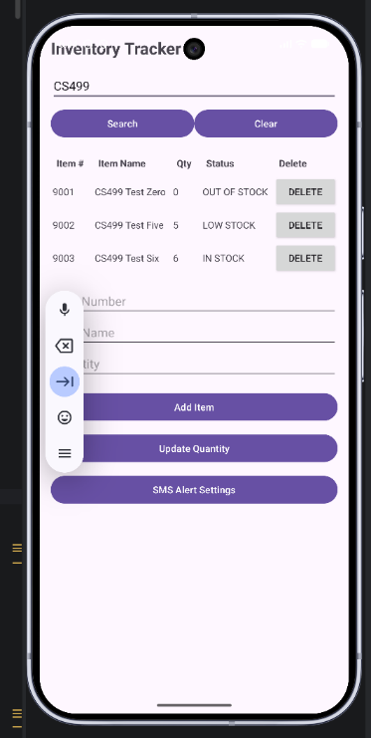
Figure 5. Multiple Search Results Test. Searching for CS499 returned three matching inventory items while excluding unrelated records.
Finally, I tested the login process using an incorrect password. The application rejected the login, kept me on the login screen, and displayed the message "Invalid username or password."
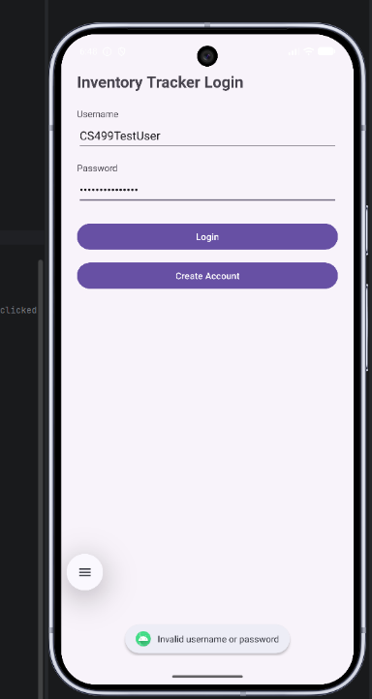
Figure 6. Incorrect-Password Test. The application rejected an incorrect password and did not allow access to the inventory screen.
Going back and testing these features helped me confirm that they worked the way I expected. It also gave me specific examples to include in response to my instructor’s feedback.
Course Outcomes
These changes met the outcomes I originally planned to focus on, mainly outcomes four and five. The new features show my ability to improve an existing application using Java, Android Studio, and SQLite. Instead of rebuilding the application, I was able to make changes that improved how users interact with it and how inventory information is displayed.
Outcome five focused on security, which I addressed by replacing plain-text password storage with salted PBKDF2 hashing and adding input validation. These changes helped me better understand how security needs to be considered when working with user accounts and stored information.
I did not make any major changes to my original outcome plan. I focused mostly on outcomes four and five with this project, while the other outcomes will be addressed through my other portfolio artifacts and professional self-assessment.
Reflection
This enhancement helped me understand how changes in one part of an application can affect other parts. I worked on one change at a time and tested each one before moving on. The password change was the most challenging because changing how passwords are stored also required changing how login verifies them. The search feature also required changes to both the database and inventory screen.
After reading my instructor's feedback, I realized I hadn't explained some of the technical details very well. I had described the changes I made, but I hadn't included enough information about how they worked or how I tested them. Going back into Android Studio and testing the stock-status boundaries, search results, and login process helped me provide that information.
One limitation I noticed is that the database currently allows duplicate item numbers. If two records have the same number, updating or deleting one could affect both. This is something I would want to improve in a future version of the application, but I decided to keep the focus on verifying and documenting the enhancements I had already completed.
Overall, the enhanced version keeps the same purpose as the original app while making it easier to use and more secure. This project also helped me see how important it is to explain and test the changes I make, instead of just assuming that the code working means everything has been covered.

